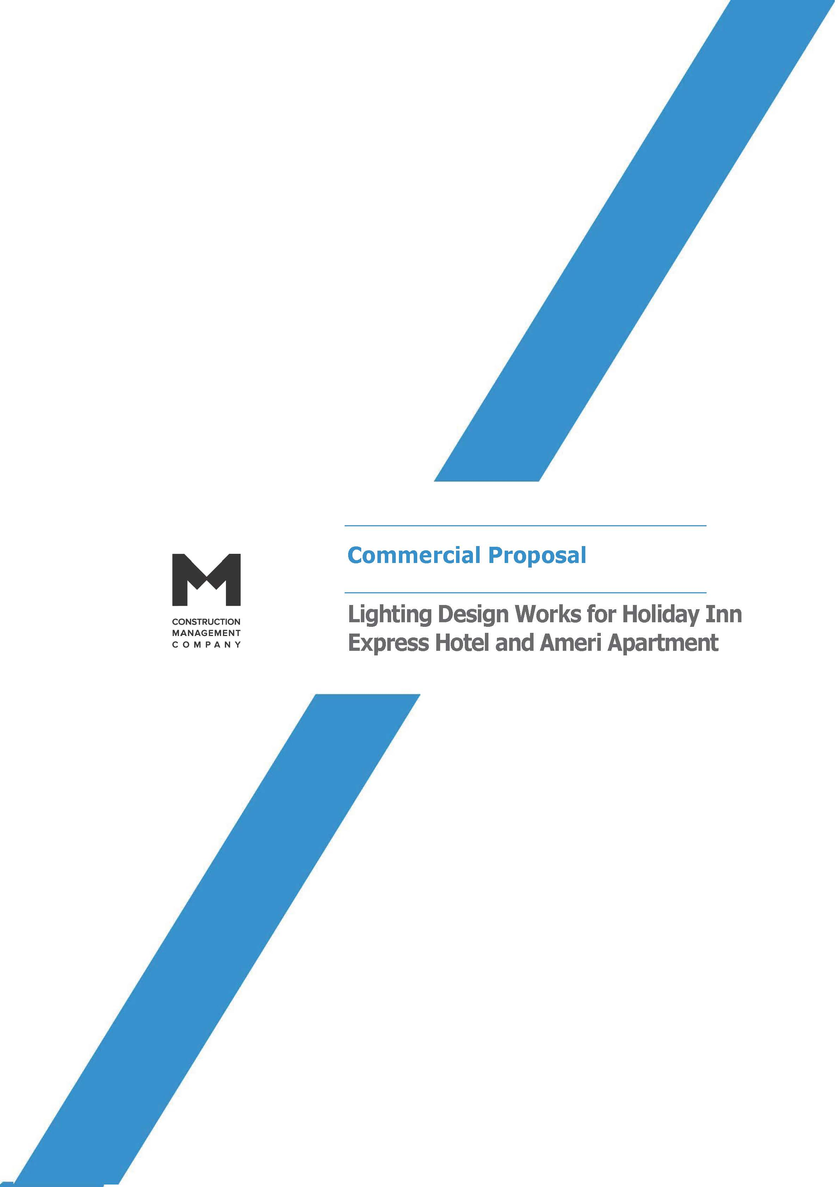

Commercial Proposal

Prepared for:
Ameri Development LLC

Prepared by:
CMC Ltd
33. I. Chavchavadze Avenue, Tbilisi 0179, Georgia
T (+995 32) 2240717

February, 24, 2020

© CMC
THIS DOCUMENT AND ALL OF ITS CONTENTS IS A PROPERTY OF CMC LTD.
IT MAY NOT BE REPRODUCED IN A WHOLE, OR IN PART, NOR MAY ANY INFORMATION
CONTAINED THEREIN BE DISCLOSED WITHOUT THE PRIOR CONSENT OF THE OWNER.

Prepared By | Project Manager | O.Bibileishvili |  | Document No | HIE-CP-004
 | Design Manager | E. Bayindir |  | Revision | 00
Approved By | CEO | G. Ioseliani |  | Date | 24-Feb-2020

COMMERCIAL PORPOSAL
Lighting Design Works for Holiday Inn Express Hotel and Ameri Apartment

To Whom It May Concern:
We are pleased to announce, that Your respectful company has passed the first, prequalification stage of the tender. Capabilities, background and experience of your company has been thoroughly studied, evaluated and found suitable to execute the Lighting design works for the mentioned project.
Applicants should note, that the information given at this stage may become a subject of consideration, renegotiation and modification as per terms of the agreement. If any error, omission or misrepresentation is discovered, the Client reserves the right to disqualify the applicant from participation in the second stage of the tender.
The form of Commercial Proposal must be signed by the authorized representative of the Consultant, sealed (stamped), scanned and uploaded to CMC tender platform www.tenderers.net not later than by the return date specified below. (instructions for the uploading of the documents to the CMC procurement platform can be found on the web page).
No additional documentation should be included unless otherwise specified.

Please send completed, signed and scanned Commercial Proposal:
Not later than: 18:00; 9th day of March 2020;
Note: Neither the Client nor Project Management Company can be held responsible for the non-receipt of Commercial Proposal or any part of it.

Only the respective fields of the present document should be filed in. In case the Consultant has any other suggestions, exceptions, queries etc. it should be shared with the Employer, please fill in respective section “Comments and Queries” (page: 3)

COMMERCIAL PROPOSAL # _______

The remuneration for the Services is a fixed fee (the “FEE) inclusive all related expenses that might be incurred by the Consultant for delivery of the agreed scope of the services in the agreed scale and time;

The currency applicable to the Agreement is United States Dollars (USD $) including VAT;

The Client and the Consultant agree that the FEE shall be USD __________________________________________ $
(in words: _______________________ & ________________________Dollar Cents Only) Including VAT and any other taxes applicable by Georgian Legislation;

The fee is inclusive of all an any expanses that might be incurred for all site visits to Tbilisi during delivery of the services;

Payment Terms
The amount shall be paid in installments under the following schedule, after full and complete delivery of the services envisaged by the present stage:
The Fee shall be paid in instalments, under the following payment schedule:

PAYMENT | SUBMISSION STAGE | DURATION | FEES, USD (INCLUDING VAT)
Installment # 1 | Schematic Design | 25 days (after signing of the agreement) | USD ________
Installment # 2 | Design Development | 25 days (after signing of the agreement) | USD ________
Installment # 3 | Tender Documentation | 30 days (after signing of the agreement) | USD ________

Total: ____________ USD
Anticipated Time for provision of full services is 80 (Eighty) Calendar days.
Payment for each respective Phases shall be made after all deliverables of the Services have been delivered fully, dully and on time.
The amount(s) due shall be paid within 15 days after the issue date of the Consultant's invoice which must be presented for payment together with the acceptance protocol evidencing that the services for the respective Phase, Stage and/or Part is completed to the Client's satisfaction, signed by both Parties;
If the Client considers that the Services are performed to the required quality the Protocol shall be signed with "NO OBJECTIONS";

Should the Client consider that defects are found in the Services, the Client will sign the protocol stating remarks and the deadline for rectification of the detects;
The Acceptance Protocol shall describe in a comprehensive manner the Services that have been delivered by the Consultant.
- The final documents delivered by the Consultant.
- If defects. are noted in the acceptance protocol, the payment shall not be validated until rectification of the noted defects will be acknowledged by both Parties in writing.
- In any cases, no payment shall be made if the respective invoice(s) is (are) not accompanied by a signed bilateral acceptance protocol - clean of any remarks and delivered final documents by the Consultant.
- All amounts are VAT included.
Additional Services
- For any additional services the Consultant will submit a fully detailed and costed proposal to the Client for approval prior to proceeding with any additional services.

- Prior to incurring any reasonable expenses, the Consultant shall be obliged to provide an itemized break-down of the value of these expenses or its estimation for the expenses value and to submit this break-down to the Client for prior approval by the Client. The Consultant shall not incur any expenses before obtaining the said approval from the Client.

AUTHORISED SIGNATURE(S) OF CONSULTANT
Signature: ___________________________________________________________
Name: ___________________________________________________________
Address: ___________________________________________________________
Comments / Queries / Exceptions (if any):
