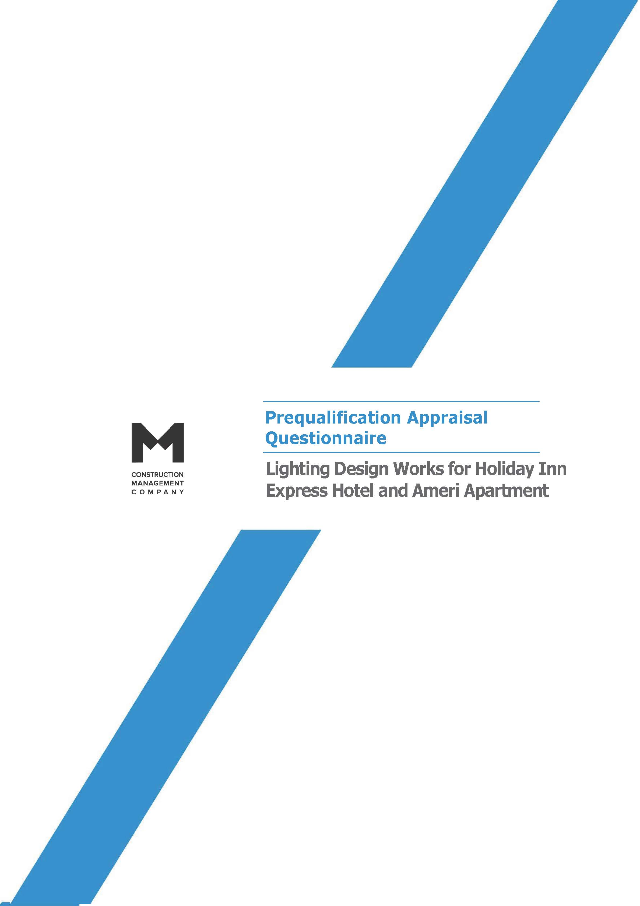

Prequalification Appraisal Questionnaire

Prepared for:
Ameri Development LLC

Prepared by:
CMC Ltd
33. I. Chavchavadze Avenue, Tbilisi 0179, Georgia
T (+995 32) 2240717

February, 24, 2019

© CMC
THIS DOCUMENT AND ALL OF ITS CONTENTS IS A PROPERTY OF CMC LTD.
IT MAY NOT BE REPRODUCED IN A WHOLE, OR IN PART, NOR MAY ANY INFORMATION
CONTAINED THEREIN BE DISCLOSED WITHOUT THE PRIOR CONSENT OF THE OWNER.

Prepared By | Project Manager | O.Bibileishvili |  | Document No | HIE-PQA-004
 | Design Manager | E. Bayindir |  | Revision | 00
Approved By | CEO | G. Ioseliani |  | Date | 24-Feb-2020

Prequalification Appraisal Questionnaire
Lighting Design Works for Holiday Inn Express Hotel and Ameri Apartment

FOREWORD
Applicants should note that, should they be successful in being awarded a contract with the Client, the Client reserves the right to terminate the contract if at any time it is discovered that the applicants have made any material misrepresentation in this application form.
Applicants should note that the information given at this stage will be subject to verification at later stages of the tendering process. If any error, omission or misrepresentation is discovered, the Client reserves the right to disqualify the applicant from participation in the tendering exercise no matter what stage in the process has been reached when the error, omission or mistake is discovered.
Applicants should understand that the information in the questionnaire and attached to the questionnaire are confidential and should not be shared with anybody.
All costs and expenses associated with the completion and submission of this pre-qualification questionnaire shall be borne solely by the applicant.

INTRODUCTION
Project is located adjacent to the 9, O.Chiladze Str. Tbilisi, Georgia. non-agricultural land of 3668 m2 ; cadastral ID 01.10.14.007.023.
The project comprises:
- Holiday Inn Express Hotel
- Hotel (with several scenarios of number of rooms 111 - 2399 sq.m. (on 2-9 Floors )
- Back of House – 1316.8 sq.m
- Front of House (FoH) – 1303.9 sq.m (including guestroom corridor area – 48 sq.m.)
- Ameri Apartment
- Apartment Hotel (with several scenarios of number of rooms 120)
- Back of house - 959.5 sq.m
- Front of House – 1283.5 sq.m (including guest room corridor area – 538 sq.m)
- Commercial space 3084.7 sq.m

Ameri Development LLC, intends to develop above mentioned premises on the land with the overall footprint of 3668 m2. The buildings are projected to be modern sophisticated that will attract guests worldwide.
CMC LLC was appointed to fulfill Pre-Construction Project Management functions for the entire Hotel development project.
The prequalification appraisal is the first stage in the process of evaluating all companies who have expressed interest, to determine their capability and suitability to execute the Lighting works for the above-mentioned project. The information provided by applicants will be utilized solely in response to prequalification process and not for any other purpose, nor it will be disclosed to any of your competitors, or any other parties.

GENERAL INSTRUCTIONS
The questionnaire must be completed in full and on time, with relevant additional information provided as appropriate.
Should you have any queries on this questionnaire or any other matters relating to the service, you should send them in writing to the attention of:
Irakli Beridze, Ops. Director CMC LLC, to the following e-mail address: i.beridze@cmc.ge

INSTRUCTIONS FOR COMPLETION OF THE QUESTIONNAIRE
All questions must be answered. The Questionnaire is to be completed electronically, signed, sealed, scanned and uploaded to CMC tender platform www.tenderers.net not later than by the return date specified below. (instructions for the uploading of the documents to the CMC procurement platform is specified in the annex “Instructions to tenderers”)

The answers to the Questionnaire must be no longer than specified. No additional documentation should be included unless otherwise specified. All supplementary and supporting documentation that is specified should be submitted in an electronic format.

Please send completed, signed and scanned Questionnaire
Not later than: 18:00; 9th day of February 2019;

Note: Neither the Client nor Project Management Company can be held responsible for the non-receipt of questionnaire or any part of it.

APPENDIX #1 – GENERAL COMPANY INFORMATION
To be completed by the MEP Consultant proposing to undertake the works. The aim of the document is to provide an insight into the technical, commercial, financial and legal status and capabilities of the proposed Design Company.
# | General Company Information
1 | Name of the Consultant (parent company, its ownership)
1.1 | Name of the authorized signatory /Director/:
1.2. | Registered office and address:
1.3. | Official address for correspondence:
1.4.  1.4.1.  1.4.2. | Contact Details  Telephone no:  e-mail:
1.5. | Company ID No:
2. | Name of sub-contractor Company #1 (if any), with indication of the relevant scope of subcontracting (Design Discipline, if any)
2.1. | Name of the authorized signatory /Director/:
2.2. | Registered office and address:
2.3. | Official address for correspondence:
2.4.  2.4.1.  2.4.2. | Contact Details  Telephone no:  e-mail:
3. | Details of the proposed guarantee or maximum range of the Professional Liability Indemnity to be issued on behalf of the Consultant covering full scope of services to be provided including scopes of sub-consultants if any
4 | Turnover (USD) over the last 3 (three) years  2017 2018 2019  _____________($) _____________($) _____________($)

2.Company History:
References from a minimum three former projects implemented during the last four years should be provided in the format attached below (preferences will be given to the design consultancy of the similar scope, i.e. Casinos, Hotels etc.):
List of Project References (template table)
Ref no: ___ | Project title: |  | __________________________________________________________________
Name of legal entity | Country | Overall Contract value (USD) | Proportion carried out by legal entity (%) | Provided staff input (person months) | Name of client | Project Dates  (start/end) | Name of consortium members (if any)
Detailed description of project: |  |  |  |  |  | Type of design services provided:
Services carried out by the Consultant include the following trades:
1.
2.
3.
etc…

5. Structure of Consultant’s Staff Resources
Only technical experts should be mentioned. Administrative or other support staff must not be included! In case of subcontracting, please provide one table per association member.

Average manpower | 2017 |  | 2018 |  | 2019
 | Total staff | Staff relevant to this project | Total staff | Staff relevant to this project | Total staff | Staff relevant to this project
Permanent staff (key experts)
Other staff (back stoppers)
Total

INSTRUCTIONS FOR COMPLETION OF THE QUESTIONNAIRE
In this section, instructions are given for completion of the Questionnaire to be found in the Appendices.
All questions must be answered.
The Questionnaire is to be completed electronically, signed, sealed, scanned and uploaded to CMC tender platform www.tenderers.net as per instructions specified and within a return date indicated above
The answers to the Questionnaire should be no longer than specified.

ADDITIONAL INFORMATION TO BE INCLUDED
- Portfolio of the Consultant, enlisting the experience and projects implemented. Similar scope of works and works implemented in Georgia will be considered as a priority.

- CVs of the Key Experts, showing their project related experience, emphasized on their input into the project.

BEFORE RETURNING YOUR APPLICATION, PLEASE ENSURE YOU HAVE:
Answered all questions appropriate to your application.
Enclosed appendices and supporting documents.
